PsyClick: Clinical Decision Support System for Detecting Single-Session Psychomotor Disturbances via EWMA-Based Multivariate Analysis

of Keystroke and Cursor Dynamics

by

Ayaay, Martonie Loreign L.
Ballano, Denise Nicole M.
Huertas, Lana Denise R.
Tablate, Judea Ann C.

Technical Documentation

FEU Institute of Technology
July 2026

©2026 Ayaay, Martonie Loreign L., Ballano, Denise Nicole M.,
Huertas, Lana Denise R., Tablate, Judea Ann C.
All Rights Reserved

1. Purpose and Scope
This document is the consolidated Technical Documentation for PsyClick Secure, required under the CS0029 Final Project Specification (Section IV.B, item 3). It contains the System Architecture Diagram, Database Schema, API Documentation, Installation Guide, and a condensed User Manual for the psyclick-secure application.
The full clinician and patient operating guide is provided as a separate User Manual deliverable; the section below summarizes the operating procedure.

2. System Architecture Diagram
PsyClick Secure applies defense in depth within a single-workstation trust boundary. A local Electron/React presentation layer communicates with a loopback Flask API (127.0.0.1:5101); server middleware authenticates bearer sessions; role checks and clinician ownership scope protected records; a fail-closed consent gate precedes telemetry capture; SQLite persistence uses parameterized queries and transactions; audit events are hash-chained; and Windows DPAPI protects exports and backups.
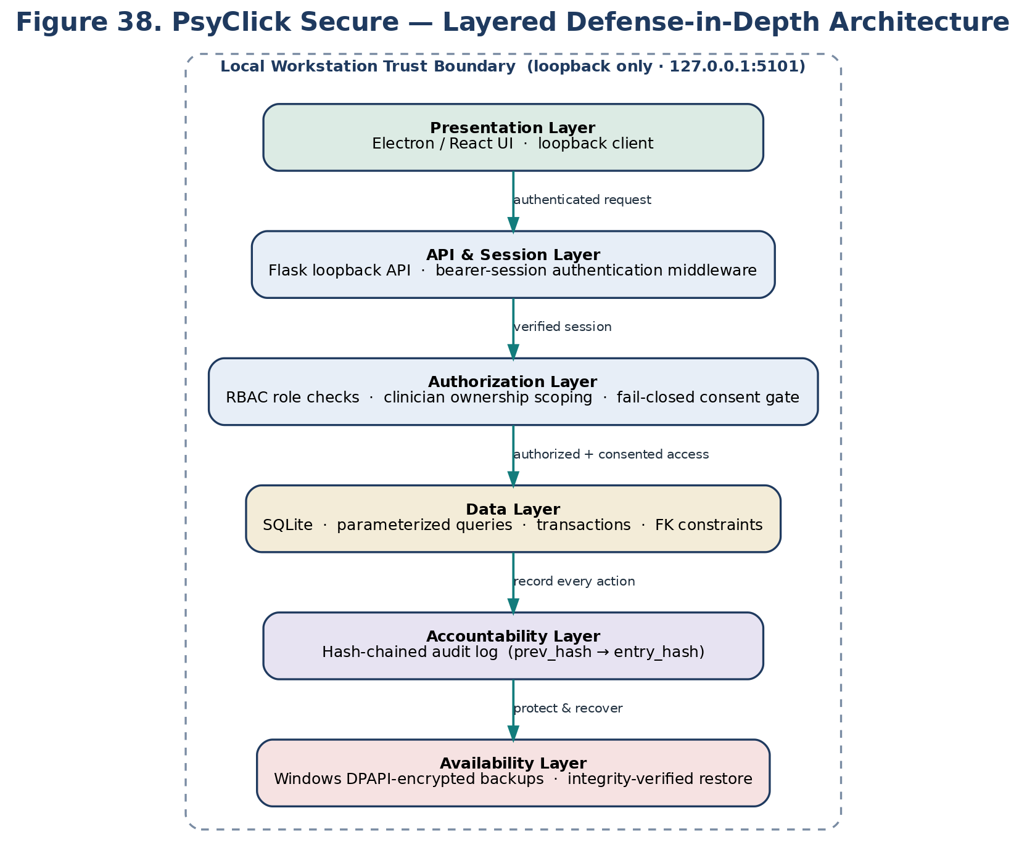
Figure 1. PsyClick Secure layered security architecture.

3. Database Schema
The secure database classifies clinician identity, sessions, consent, clinical/behavioral records, audit evidence, and recovery metadata. Direct SQL string concatenation is prohibited; parameterized queries, foreign-key constraints, transaction boundaries, and application-level authorization are required.
Entity | Primary Key | Security-Relevant Fields | Classification
clinicians | clinician_id | scrypt password_hash; role; status; failed_attempts; locked_until | Restricted identity
security_sessions | session_id | token_hash; clinician_id; role; last_seen_at; expires_at; revoked_at | Confidential session metadata
consent_records | consent_id | patient_id; clinician_id; consent_version; decision; recorded_at; withdrawn_at | Restricted consent
intake_sessions | session_id | patient/session identifiers; features; scores; flag; rationale | Restricted clinical/behavioral
audit_log | log_id | actor; actor_id; action; outcome; prev_hash; entry_hash; timestamp | Confidential accountability
backup_records | backup_id | created_by; file_path; SHA-256; encrypted; status; verified_at | Confidential recovery metadata

The security-aware entity-relationship diagram is shown below.
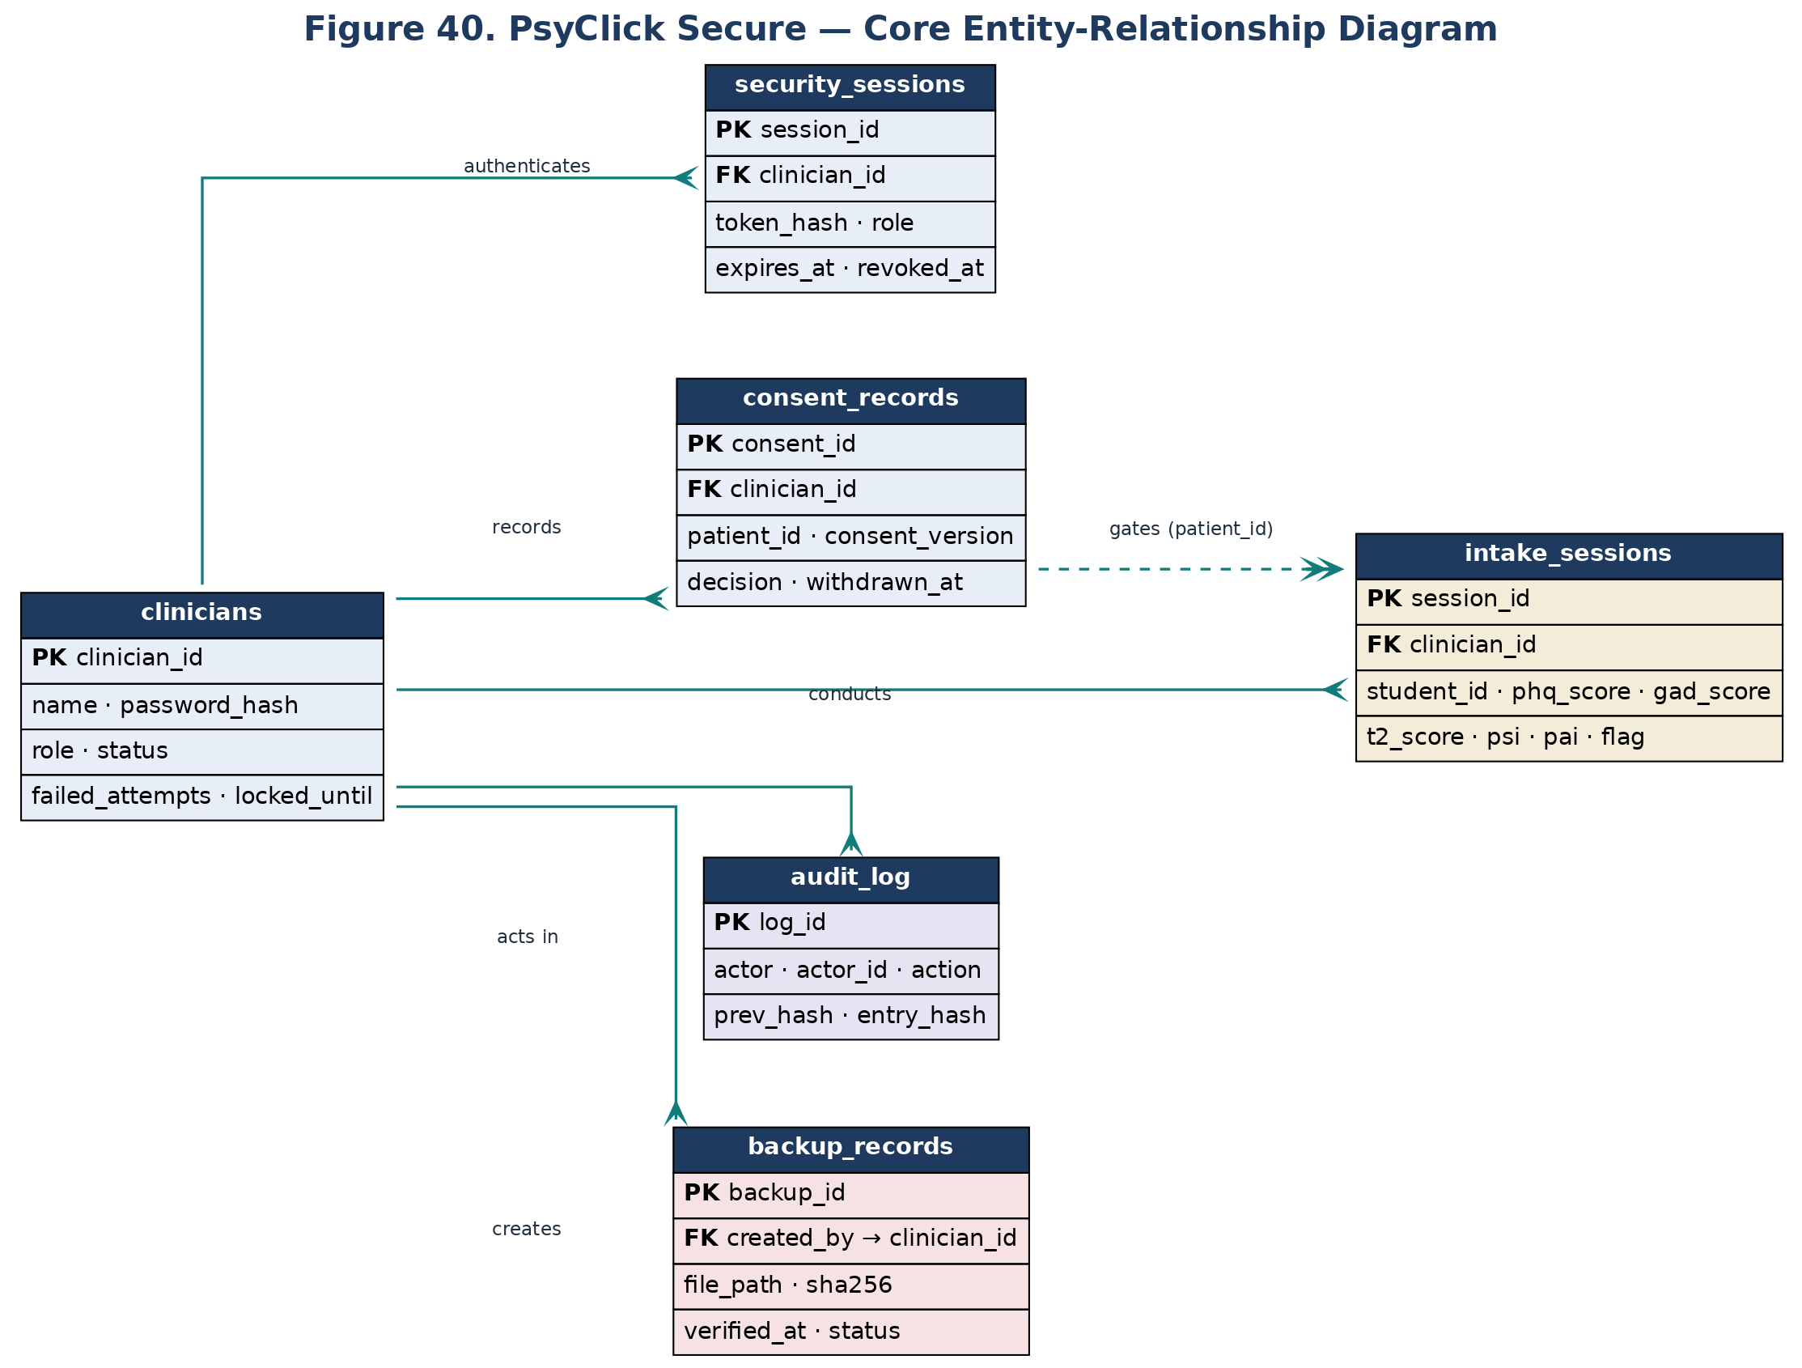
Figure 2. Core entity-relationship diagram.

4. API Documentation
All endpoints are served from the loopback Flask API at http://127.0.0.1:5101/api/ and require an authenticated bearer session except for login, first-account bootstrap registration, and the readiness ping. Access is enforced by role-based middleware.

Authentication
POST /api/login, POST /api/register (bootstrap or admin-invoked), POST /api/verify-clinician, POST /api/logout

Clinical workflow
POST /api/intake/start, GET /api/next-client-id, GET /api/next-tester-id, calibration (keyboard/mouse start and save), PHQ-9/GAD-7 and emotional-task assessment routes, POST /api/assessment/finish

Records and reporting
GET /api/stats, GET /api/sessions/recent, GET /api/session/<id>, GET /api/patients, GET /api/patients/<id>/sessions, POST /api/export/report, POST /api/export/summary

Audit and security monitoring
GET /api/audit (admin, auditor), POST /api/audit/log, GET /api/audit/verify (admin, auditor) — hash-chain verification, GET /api/security/intrusion-alerts (admin, auditor)

Administration
GET /api/admin/users (admin), PATCH /api/admin/users/<id> (admin), POST /api/admin/backup, POST /api/admin/backup/verify, GET /api/admin/security-status (admin)

Sync and health
GET /api/ping, GET /api/db-health, GET /api/sync/status, POST /api/sync/now, POST /api/sync/pull (optional Supabase cloud sync; no-op if unconfigured)

Normative / research mode
POST /api/normative/login, POST /api/normative/mode, GET /api/normative/stats, POST /api/normative/compute, GET /api/normative/compare/<id>

5. Installation Guide
On a supported Windows workstation:
• Create a Python virtual environment and install requirements.txt.
• For a packaged/controlled deployment, set the PSYCLICK_SECURE_HOME environment variable for the secure data directory (defaults to %APPDATA%\PsyClickSecure).
• Build the backend and frontend with BUILD_SECURE.bat (PyInstaller creates dist-python\psyclick_api\psyclick_api.exe; Vite builds the frontend).
• To run in development, start api_server.py on 127.0.0.1:5101, install frontend dependencies, and run npm run dev — or use start_secure.bat.
• To produce the installable desktop app, run npm run dist:installer in the frontend folder.
• Launch the application and create the first administrator account; further accounts require an administrator session.
The separate source archive and frontend build archive are supplied. A fresh independent-workstation installation still requires recorded evidence.

6. User Manual (Summary)
The full Clinician Manual and Patient Guide are provided as a separate User Manual deliverable. The core operating procedure is:
• Sign in with an individual clinician account and confirm the API readiness indicator.
• Create a pseudonymous client and record informed consent (capture is blocked until consent is recorded).
• Run keyboard and mouse calibration, then administer PHQ-9, GAD-7, and the emotional-task prompts.
• Review the dashboard — T², PSI/PAI, confidence, and the Green/Amber/Red signal — alongside clinical observation.
• Export only to an approved protected destination; exports and backups are DPAPI-encrypted with a SHA-256 check.
• Review the audit log, log out, and lock the workstation.

7. Approval
Name | Signature
Ayaay, Martonie Loreign L.
Ballano, Denise Nicole M.
Huertas, Lana Denise R.
Tablate, Judea Ann C.

